# Final Correct RSI Strategy with Signal Weighting

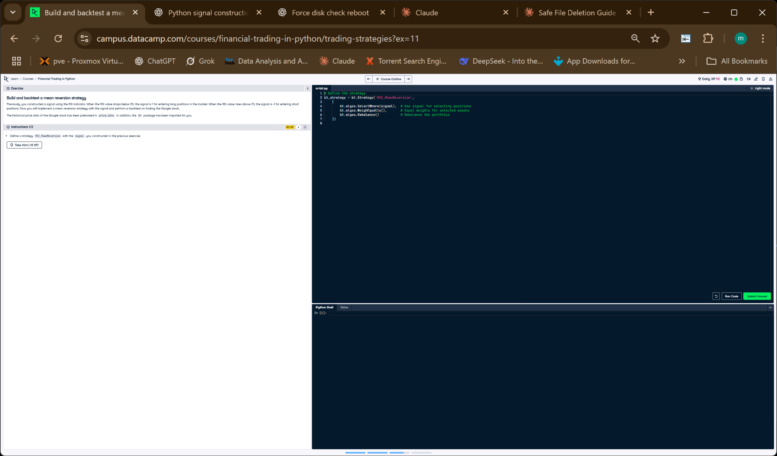

Figure: Strategy editor showing signal application. The correct approach uses WeighTarget instead of WeighEqually.

## Python Code

# Define the strategy  
bt_strategy = bt.Strategy('RSI_MeanReversion',  
 [  
 bt.algos.SelectWhere(signal), # Use signal to select positions  
 bt.algos.WeighTarget(signal), # Apply signal values (1, -1, 0) as weights  
 bt.algos.Rebalance() # Rebalance portfolio according to weights  
 ])

## Explanation

This corrected version of the strategy uses `WeighTarget(signal)` instead of `WeighEqually()`. This ensures the portfolio actually follows the intended RSI-based trading signals: 1 for long positions, -1 for short positions, and 0 for no position. The portfolio is rebalanced using these weights.